Họ Và Tên : Lê Hữu Hoàn  
Mã SV: 20IT684

Exercise 1: Write a program with the following requirements:

a Enter two integer numbers a and b; one operator (+-*/) from the keyboard.

b Print the result of the expression: a (+-*/) b  
code :

|  |
| --- |
| double a, b, result =0;  string opera= "";  Console.WriteLine("Nhap a = ");  a = double.Parse(Console.ReadLine());  Console.WriteLine("Nhap b = ");  b = double.Parse(Console.ReadLine());  while (opera != "+" && opera != "-" && opera != "*" &&opera != "/")  {  Console.WriteLine("Nhap operator (+,-,*,/) = ");  opera = Console.ReadLine();  }  if (opera == "+") result = a + b;  if (opera == "-") result = a - b;  if (opera == "*") result = a * b;  if (opera == "/")  {  if (b == 0) return;  result = a / b;  }  Console.WriteLine($"Ket Qua {a} {opera} {b} = {result}"); |

Kết Quả

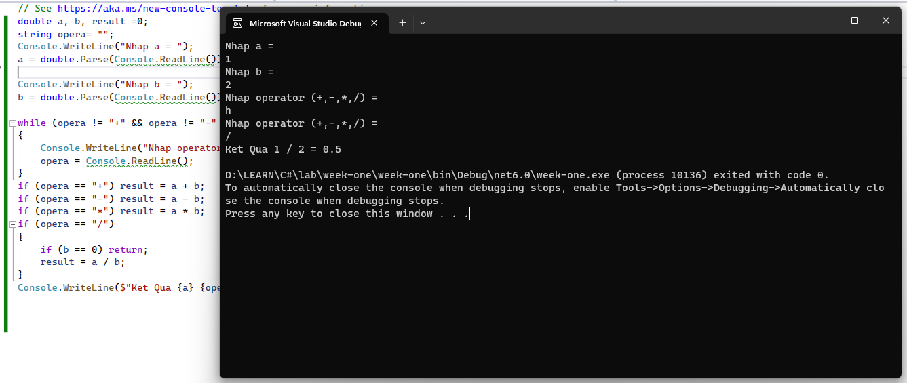

Exercise 2: Write a program to find Roots of Quadratic Equation: ax 2 +bx+c=0

Code :

|  |
| --- |
| int a, b, c;  double d, x1, x2;  Console.Write("Input a : ");  a = Convert.ToInt32(Console.ReadLine());  Console.Write("Input b : ");  b = Convert.ToInt32(Console.ReadLine());  Console.Write("Input c : ");  c = Convert.ToInt32(Console.ReadLine());  d = b * b - 4 * a * c;  if (d == 0)  {  Console.Write("Both roots are equal.\n");  x1 = -b / (2.0 * a);  x2 = x1;  Console.Write("x1 = {0}\n", x1);  Console.Write("x2 = {0}\n", x2);  }  else if (d > 0)  {  Console.Write("Both roots are real and diff-2\n");  x1 = (-b + Math.Sqrt(d)) / (2 * a);  x2 = (-b - Math.Sqrt(d)) / (2 * a);  Console.Write("x1 = {0}\n", x1);  Console.Write("x2 = {0}\n", x2);  }  else  Console.Write("No Solution. \n\n"); |

Kết quả

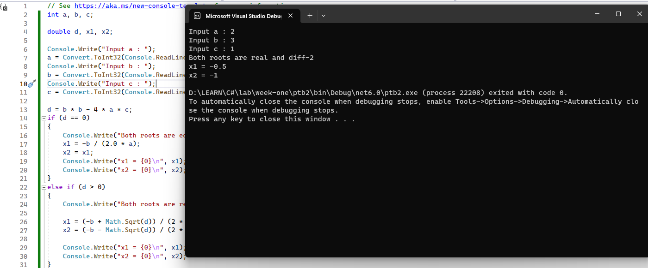

Exercise 3: Prime Number Program in C#, we will take an input n from the user; the

program will ask the user to reenter n if n&lt;2 and check whether the number is prime or

not.  
Code:

|  |
| --- |
| int number = 0;  while (number <2)  {  Console.WriteLine("Nhap 1 so = ");  number = int.Parse(Console.ReadLine());  }  for (int i = 2; i < number / 2; i++)  {  if (number % i == 0)  {  Console.Write($"{number} khong phai so nguyen to.");  return;  }  }  Console.Write($"{number} la so nguyen to."); |

Kết quả :

Exercise 4: Write a program to create A Number Guessing Game with the following requirements:

1The program begins by randomly generating a number between 1 and 100 2 The Game prompts a user to input a number.

3 The random number is the winning number used to compare against the user’s guessing number.

4 The Game will give a user 7 chances for the user to guess a randomly generated number.

5 If the user guesses wrong, the program will announce the number guessed is smaller or bigger than the winning number.

Code:

|  |
| --- |
| int lootbox = new Random().Next(0, 101);  int number;  for (int i = 1; i <= 7; i++)  {  Console.WriteLine("Nhap vao so");  number = int.Parse(Console.ReadLine());  if(number == lootbox)  {  Console.WriteLine($"Congratulation! con so may man la {lootbox}");  break;  }  else if (number < lootbox)  {  Console.WriteLine($"Lucky number greater than {number}");  }  else if (number > lootbox)  {  Console.WriteLine($"Lucky number less than {number}");  }  } |

Kết quả :  
